1. Multiple Inheritance – Professor Salary

Code

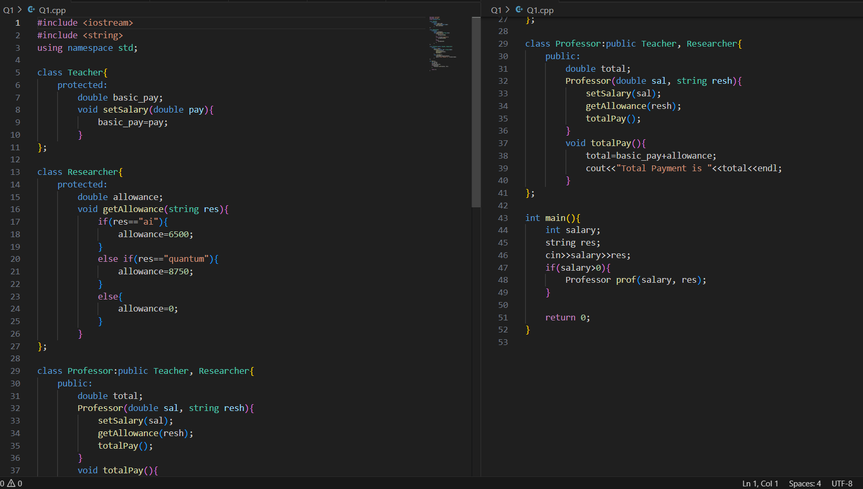

Output

1. Multilevel Inheritance – Student Marks

Code

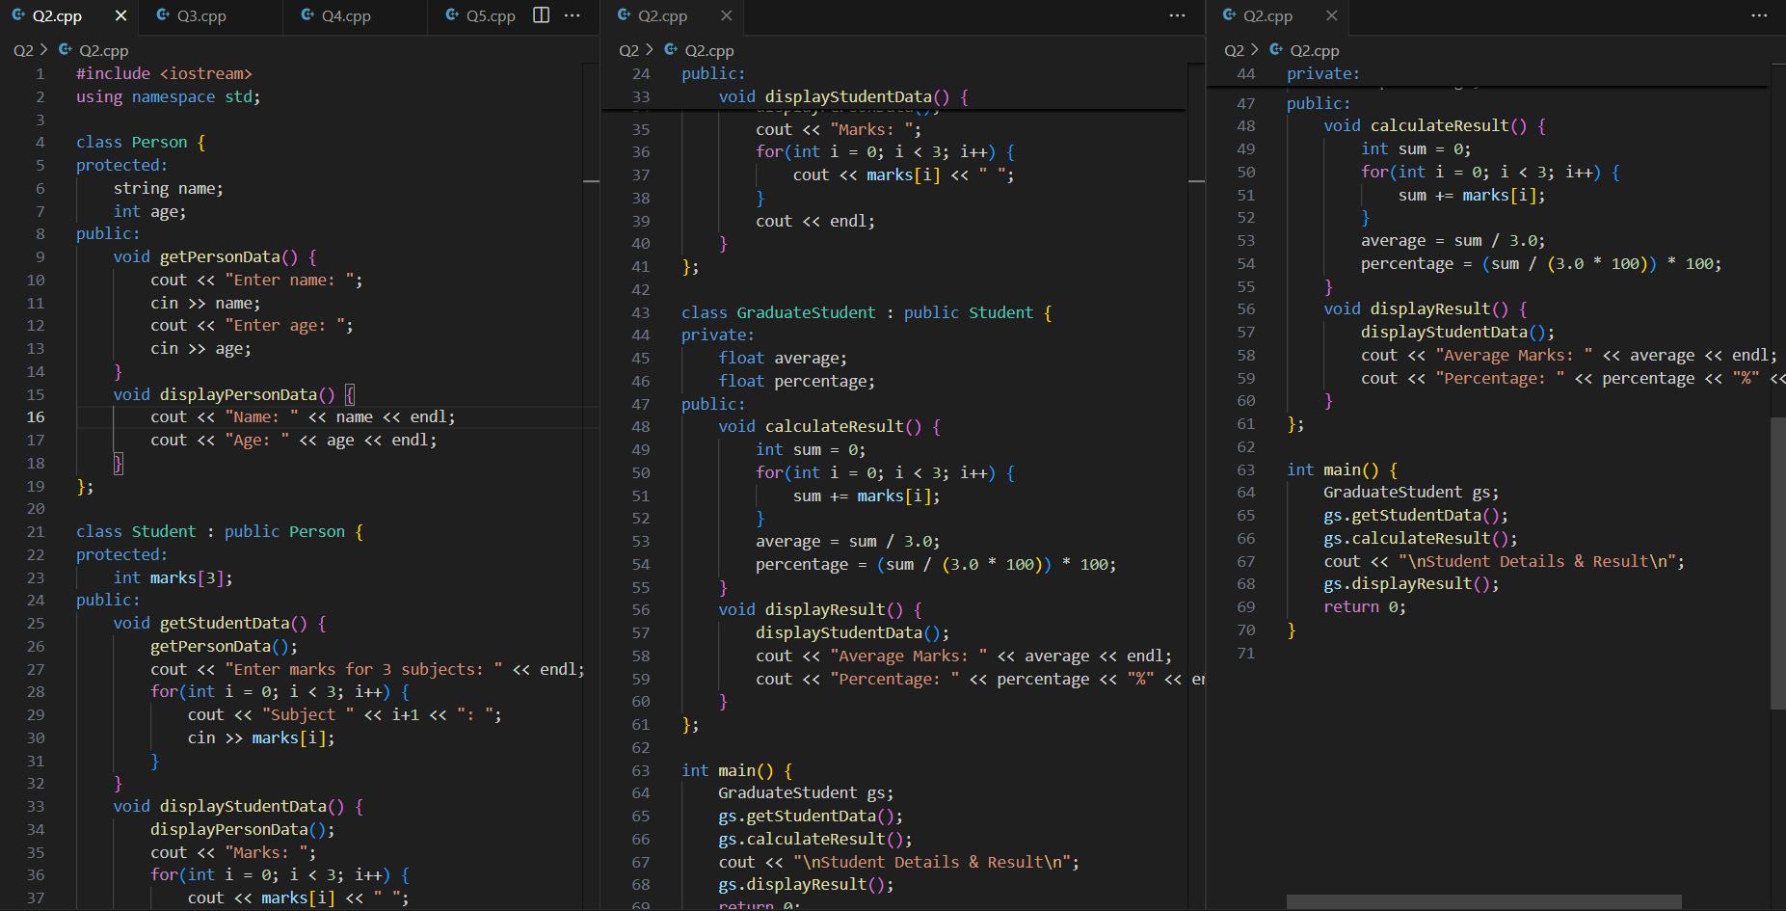

Output

1. Constructor Execution Order – Bonus Calculation

Code

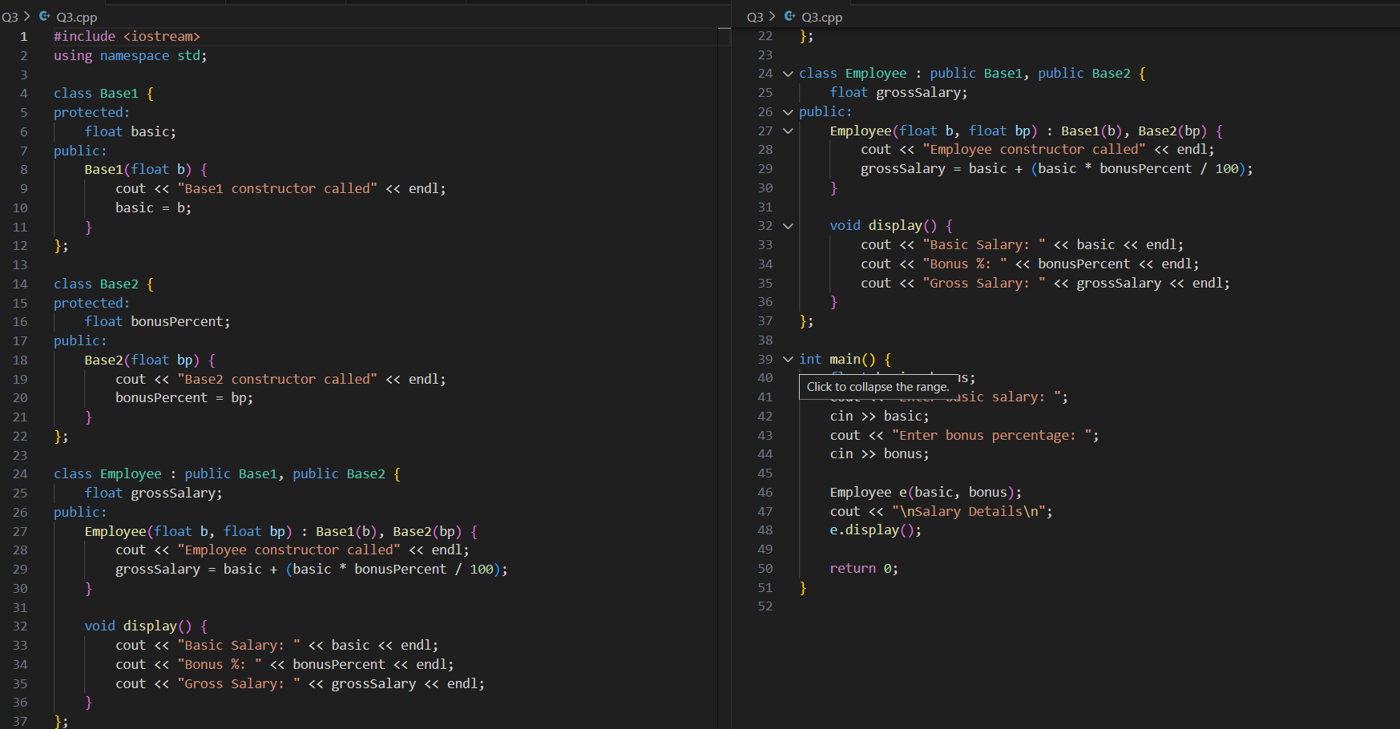

Output

1. Ambiguity in Multiple Inheritance – Area Calculation

Code

Output

1. Diamond Problem – Student Grades

Code

Output

1. Multilevel – Animal Energy

Code

Output

1. Multiple Inheritance – Duck Motion

Code

Output

1. Access Specifiers – Marks Calculation

Code

Output

1. Multiple Inheritance – Resolving Same Variable

Code

Output

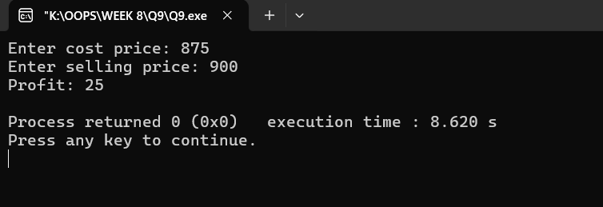

1. Real-World Manager Salary

Code

Output

